**WEEK-3**

**Exercise 1: Configuring a Basic Spring Application**

**Scenario: Your company is developing a web application for managing a library. You need to use the Spring Framework to handle the backend operations.**

**CODE:**

**MainApp.java:**

package com.library;

import com.library.service.BookService;

import org.springframework.context.ApplicationContext;

import org.springframework.context.support.ClassPathXmlApplicationContext;

public class MainApp {

public static void main(String[] args) {

ApplicationContext context =

new ClassPathXmlApplicationContext("applicationContext.xml");

BookService bookService = (BookService) context.getBean("bookService");

bookService.displayBook();

}

}

**BookService.java:**

package com.library.service;

import com.library.repository.BookRepository;

public class BookService {

private BookRepository bookRepository;

public void setBookRepository(BookRepository bookRepository) {

this.bookRepository = bookRepository;

}

public void displayBook() {

System.out.println(bookRepository.getBookDetails());

}

}

**BookRepository.java:**

package com.library.repository;

public class BookRepository {

public String getBookDetails() {

return "Book: Effective Java by Joshua Bloch";

}

}

**ApplicationContext.xml:**

<?xml version="1.0" encoding="UTF-8"?>

<beans xmlns="http://www.springframework.org/schema/beans"

xmlns:xsi="http://www.w3.org/2001/XMLSchema-instance"

xsi:schemaLocation="

http://www.springframework.org/schema/beans

http://www.springframework.org/schema/beans/spring-beans.xsd">

<!-- Repository Bean -->

<bean id="bookRepository" class="com.library.repository.BookRepository"/>

<!-- Service Bean with Dependency Injection -->

<bean id="bookService" class="com.library.service.BookService">

<property name="bookRepository" ref="bookRepository"/>

</bean>

</beans>

**pom.xml:**

<project xmlns="http://maven.apache.org/POM/4.0.0"

xmlns:xsi="http://www.w3.org/2001/XMLSchema-instance"

xsi:schemaLocation="http://maven.apache.org/POM/4.0.0

http://maven.apache.org/xsd/maven-4.0.0.xsd">

<modelVersion>4.0.0</modelVersion>

<groupId>com.library</groupId>

<artifactId>LibraryManagement</artifactId>

<version>1.0-SNAPSHOT</version>

<properties>

<java.version>1.8</java.version>

<maven.compiler.source>${java.version}</maven.compiler.source>

<maven.compiler.target>${java.version}</maven.compiler.target>

</properties>

<dependencies>

<!-- Spring Core + Beans + Context -->

<dependency>

<groupId>org.springframework</groupId>

<artifactId>spring-context</artifactId>

<version>5.3.31</version>

</dependency>

</dependencies>

<build>

<plugins>

<!-- Maven Compiler Plugin -->

<plugin>

<groupId>org.apache.maven.plugins</groupId>

<artifactId>maven-compiler-plugin</artifactId>

<version>3.10.1</version>

<configuration>

<source>${java.version}</source>

<target>${java.version}</target>

</configuration>

</plugin>

</plugins>

</build>

</project>

**OUTPUT:**

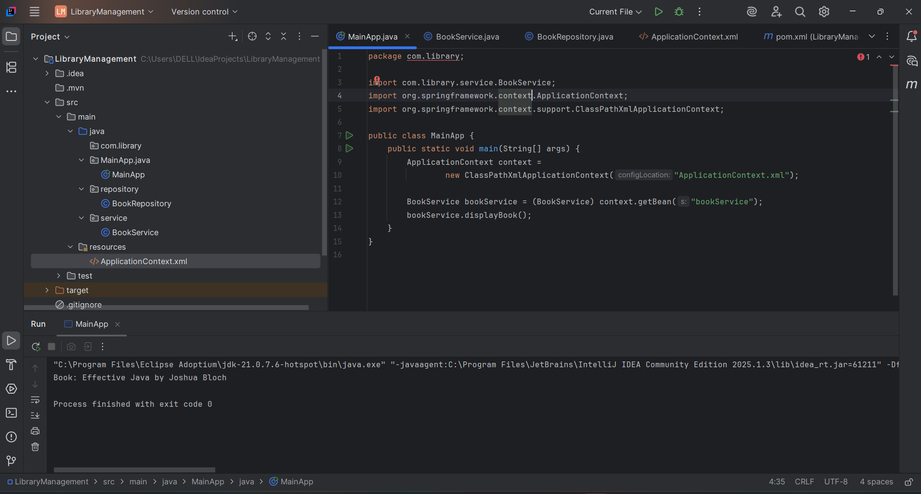

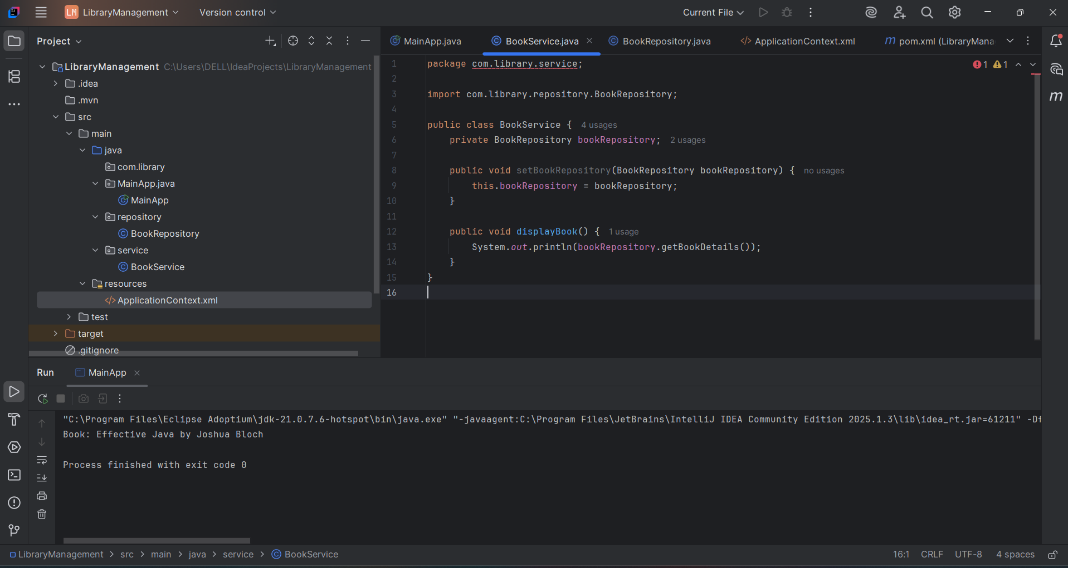

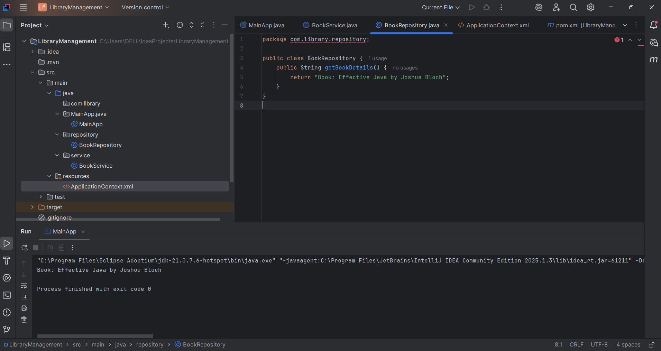

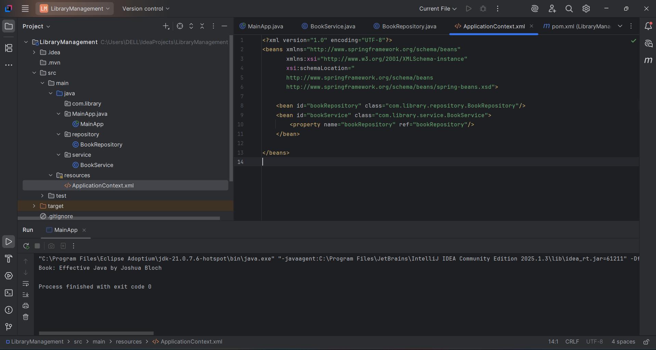

**Exercise 2: Implementing Dependency Injection**

**Scenario: In the library management application, you need to manage the dependencies between the BookService and BookRepository classes using Spring's IoC and DI.**

**CODE:**

**LibraryManagementApplication.java:**

package com.library;

import com.library.service.BookService;

import org.springframework.context.ApplicationContext;

import org.springframework.context.support.ClassPathXmlApplicationContext;

public class LibraryManagementApplication {

public static void main(String[] args) {

// Load Spring container from applicationContext.xml

ApplicationContext context = new ClassPathXmlApplicationContext("applicationContext.xml");

// Get BookService bean

BookService bookService = (BookService) context.getBean("bookService");

// Call service method to verify DI

bookService.displayBookInfo();

}

}

**BookService.java:**

package com.library.service;

import com.library.repository.BookRepository;

public class BookService {

private BookRepository bookRepository;

// Setter method for Spring to inject the dependency

public void setBookRepository(BookRepository bookRepository) {

this.bookRepository = bookRepository;

}

public void displayBookInfo() {

String book = bookRepository.getBookDetails();

System.out.println("Fetching Book Details...");

System.out.println(book);

}

}

**BookRepository.java:**

package com.library.repository;

public class BookRepository {

public String getBookDetails() {

return "Book: Clean Code by Robert C. Martin";

}

}

**ApplicationContext.xml:**

<?xml version="1.0" encoding="UTF-8"?>

<beans xmlns="http://www.springframework.org/schema/beans"

xmlns:xsi="http://www.w3.org/2001/XMLSchema-instance"

xsi:schemaLocation="

http://www.springframework.org/schema/beans

http://www.springframework.org/schema/beans/spring-beans.xsd">

<!-- BookRepository bean -->

<bean id="bookRepository" class="com.library.repository.BookRepository"/>

<!-- BookService bean with DI (setter) -->

<bean id="bookService" class="com.library.service.BookService">

<property name="bookRepository" ref="bookRepository"/>

</bean>

</beans>

**Pom.xml:**

<project xmlns="http://maven.apache.org/POM/4.0.0"

xmlns:xsi="http://www.w3.org/2001/XMLSchema-instance"

xsi:schemaLocation="http://maven.apache.org/POM/4.0.0

http://maven.apache.org/xsd/maven-4.0.0.xsd">

<modelVersion>4.0.0</modelVersion>

<groupId>com.library</groupId>

<artifactId>LibraryManagement</artifactId>

<version>1.0-SNAPSHOT</version>

<properties>

<java.version>1.8</java.version>

<maven.compiler.source>${java.version}</maven.compiler.source>

<maven.compiler.target>${java.version}</maven.compiler.target>

</properties>

<dependencies>

<!-- Spring Core + Beans + Context -->

<dependency>

<groupId>org.springframework</groupId>

<artifactId>spring-context</artifactId>

<version>5.3.31</version>

</dependency>

</dependencies>

<build>

<plugins>

<!-- Maven Compiler Plugin -->

<plugin>

<groupId>org.apache.maven.plugins</groupId>

<artifactId>maven-compiler-plugin</artifactId>

<version>3.10.1</version>

<configuration>

<source>${java.version}</source>

<target>${java.version}</target>

</configuration>

</plugin>

</plugins>

</build>

</project>

**OUTPUT:**

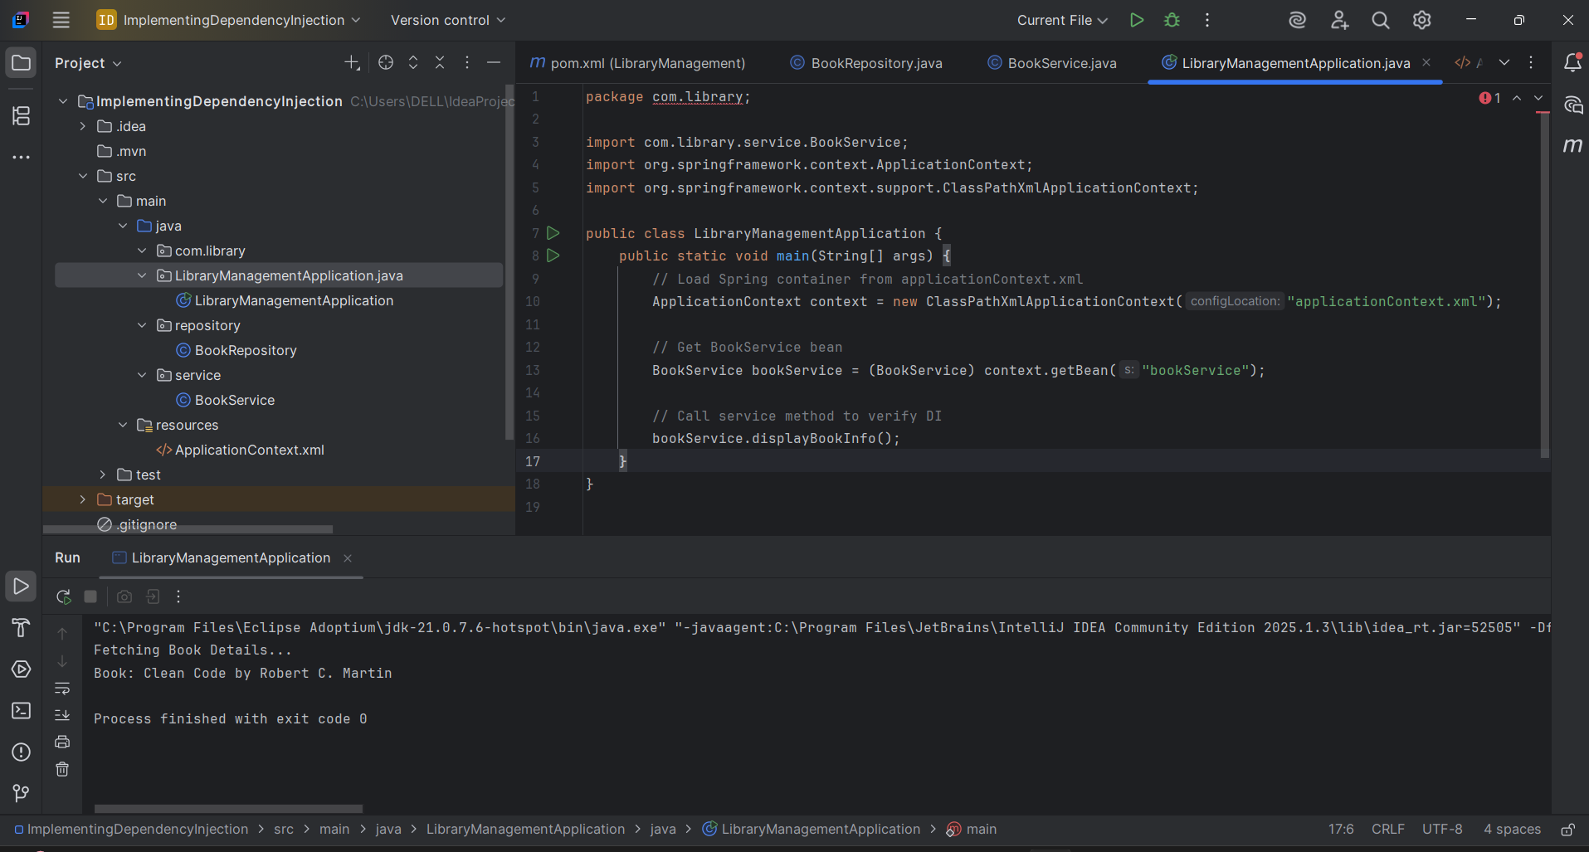

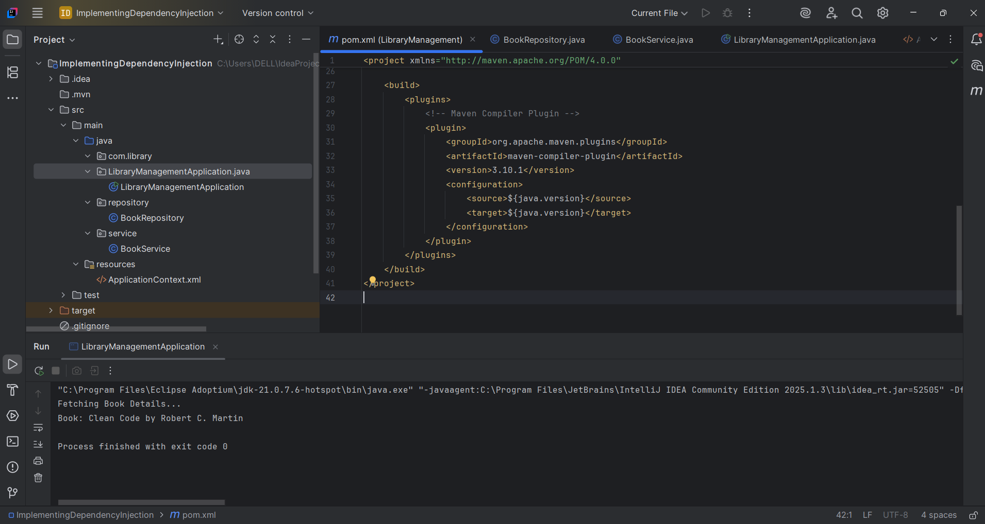

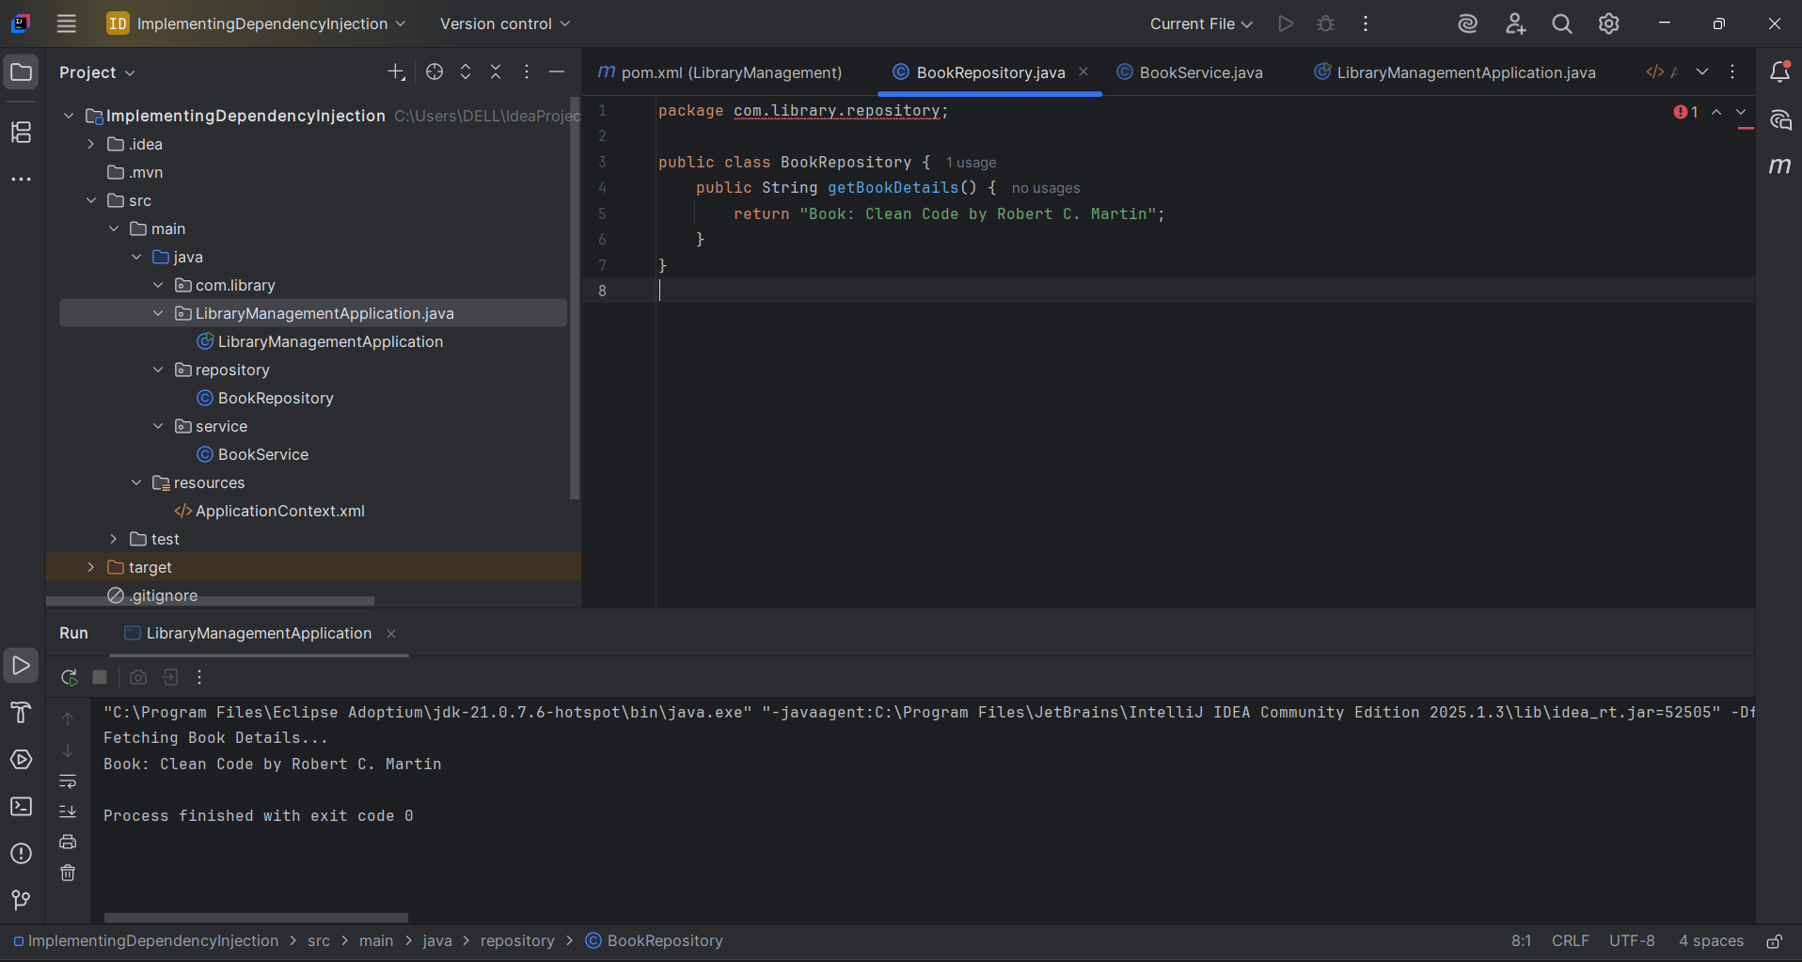

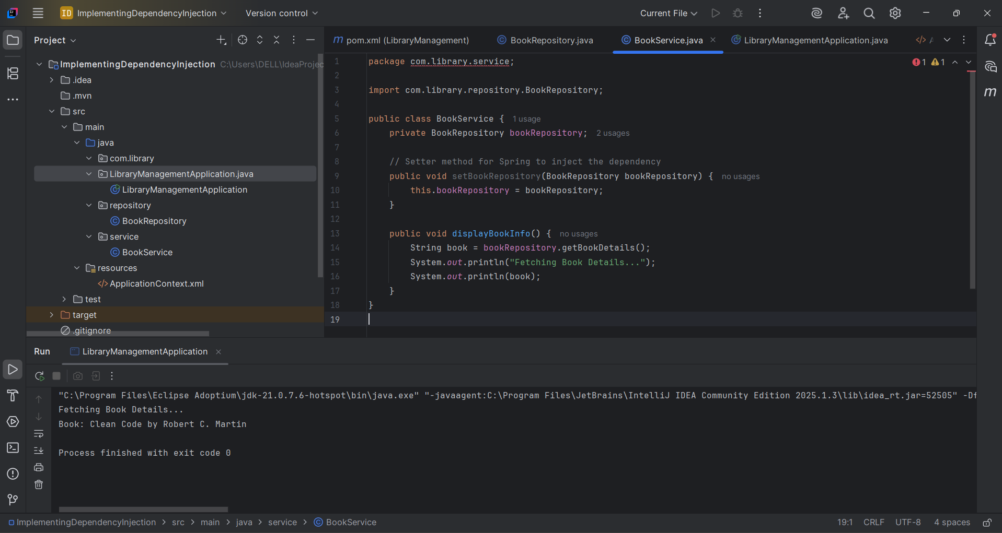

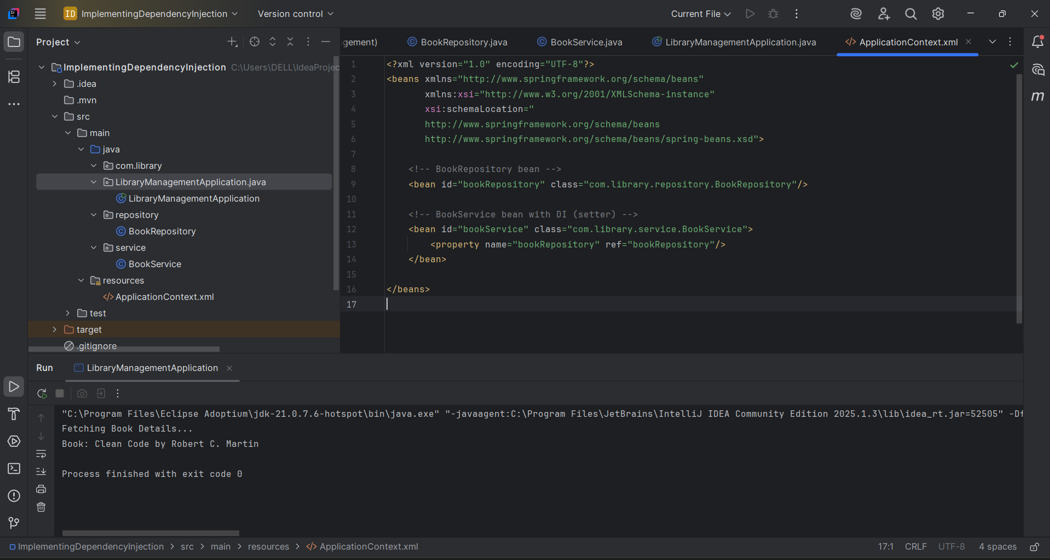

**Exercise 4: Creating and Configuring a Maven Project**

**Scenario: You need to set up a new Maven project for the library management application and add Spring dependencies.**

**CODE:**

**TextApp.java:**

package com.library;

import org.springframework.context.support.ClassPathXmlApplicationContext;

public class TestApp {

public static void main(String[] args) {

System.out.println("Spring project configured successfully!");

}

}

**pom.xml:**

<project xmlns="http://maven.apache.org/POM/4.0.0"

xmlns:xsi="http://www.w3.org/2001/XMLSchema-instance"

xsi:schemaLocation="http://maven.apache.org/POM/4.0.0

http://maven.apache.org/xsd/maven-4.0.0.xsd">

<modelVersion>4.0.0</modelVersion>

<groupId>com.library</groupId>

<artifactId>LibraryManagement</artifactId>

<version>1.0-SNAPSHOT</version>

<properties>

<java.version>1.8</java.version>

<maven.compiler.source>${java.version}</maven.compiler.source>

<maven.compiler.target>${java.version}</maven.compiler.target>

</properties>

<dependencies>

<!-- Spring Core + Context -->

<dependency>

<groupId>org.springframework</groupId>

<artifactId>spring-context</artifactId>

<version>5.3.31</version>

</dependency>

<!-- Spring AOP -->

<dependency>

<groupId>org.springframework</groupId>

<artifactId>spring-aop</artifactId>

<version>5.3.31</version>

</dependency>

<!-- Spring Web MVC -->

<dependency>

<groupId>org.springframework</groupId>

<artifactId>spring-webmvc</artifactId>

<version>5.3.31</version>

</dependency>

<!-- Servlet API for WebMVC (optional) -->

<dependency>

<groupId>javax.servlet</groupId>

<artifactId>javax.servlet-api</artifactId>

<version>4.0.1</version>

<scope>provided</scope>

</dependency>

</dependencies>

<build>

<plugins>

<!-- Maven Compiler Plugin -->

<plugin>

<groupId>org.apache.maven.plugins</groupId>

<artifactId>maven-compiler-plugin</artifactId>

<version>3.10.1</version>

<configuration>

<source>${java.version}</source>

<target>${java.version}</target>

</configuration>

</plugin>

</plugins>

</build>

</project>

**OUTPUT:**

